

SIMATS ENGINEERING
Saveetha Institute of Medical and Technical Sciences Chennai- 602105
Student Name: T. Subahan Reg. No.: 192511121
Course Code: CSA0711 Slot: D
Course Name: Computer Networks
Course Faculty: Dr. R. Shankar

Project Title: Real-Time Subnet Scanning and Network Topology Visualization
Module Photographs: (3 photographs –Module Photo, Individual student contribution module work in the project and presentation image)
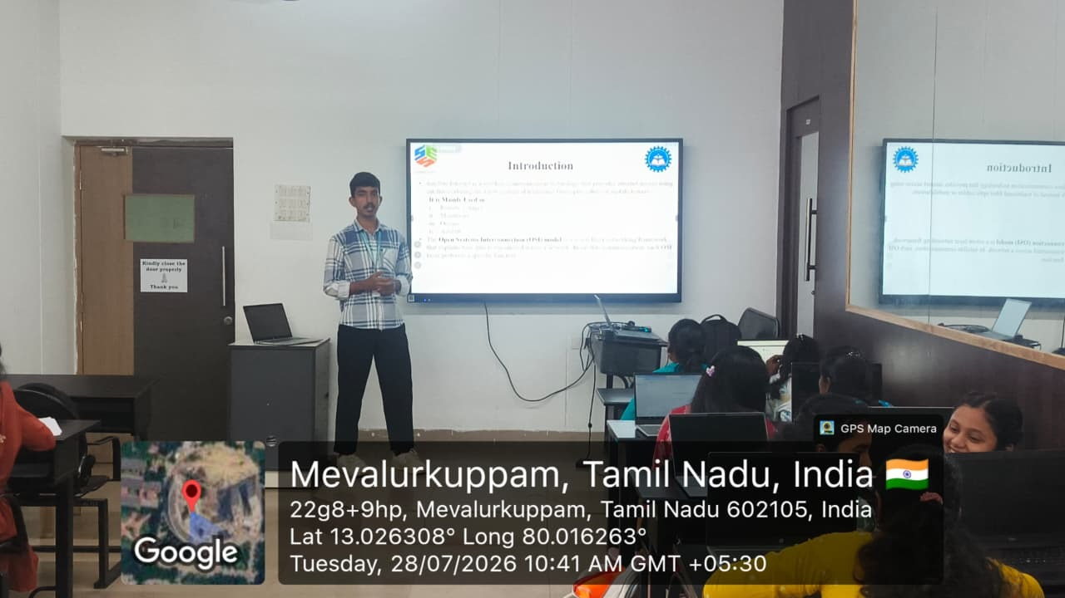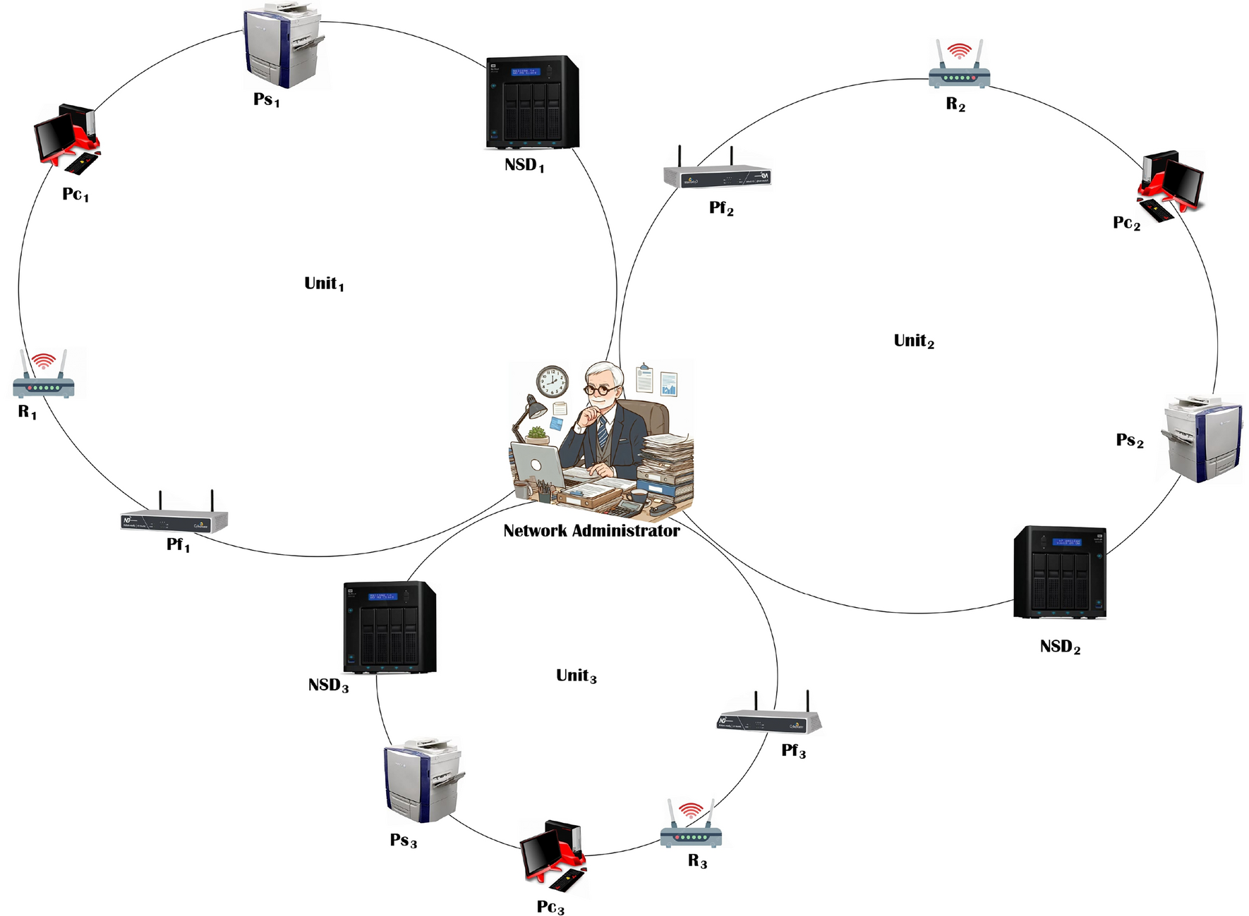
Project Description: (here you write what you did in this project (contribution) including Model Description
Real-Time Subnet Scanning is a network monitoring process that continuously scans a specified subnet to identify active devices and collect their network information. The system detects devices using their IP addresses, MAC addresses, hostnames, and connectivity status. By performing periodic or real-time scans, it can quickly identify newly connected or disconnected devices and keep the network information updated. This scanned data is then processed and used to generate a dynamic network topology, allowing administrators to visualize how devices are connected and monitor changes in the network efficiently.
The system performs network scanning at regular intervals to obtain updated information about the connected devices. It can collect details such as IP address, MAC address, hostname, device status, and response time. Techniques such as ICMP ping, ARP requests, and TCP/UDP port scanning can be used to determine whether a device is active and reachable. The collected information is then passed to the network data processing module for further analysis.
.

Student Signature Guide Signature

